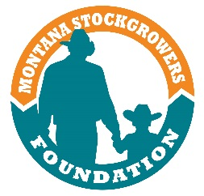

2019 NCBA Young Cattlemen’s Conference

May 29th-June 7th
Now submit your application online! Just go to mtbeef.org.

Name: _________________________________________________ Age: ___________________

Address: ________________________________________________________________________

Town: _____________________________ State: ____________________ Zip: ______________

Daytime Phone: ___________________________ Evening Phone: _________________________

Type of Cattle Operation (e.g., commercial, seedstock, etc.): _______________________________

Please describe your role in the operation:_______________________________________________
________________________________________________________________________________________________________________________________________________________________________________________________________________________________________________

***You must be a current member of MSGA and NCBA to participate***

Please list your beef industry leadership activities, particularly Montana Stockgrowers or NCBA:
(e.g., committees, Young Stockgrowers Conference, etc. Use another page if necessary.)
________________________________________________________________________________________________________________________________________________________________________________________________________________________________________________________________________________________________________________________________
In no more than 200 words, please tell us how you, as an individual member, can help MSGA address some of the issues facing the beef industry. (Please answer on separate page.)

Two letters of reference are required
Please mail or fax to MSGA Foundation at the following address:
MSGA Foundation YCC
Attn: Kori Anderson
420 N. California St.
Helena, MT 59601
kori@mtbeef.org
Fax (406) 449-5105

Applications and references must be received at the MSGA office by March 15, 2019.

The NCBA Young Cattlemen’s Conference, held in June, is an opportunity for cattlemen between the ages of 25 and 50 to visit segments of the beef industry in other parts of our nation with young cattlemen from other states. The Foundation will ensure funding for the full cost of the tour along with $500 for travel expenses. Remaining expenses are the responsibility of the participant, who will be chosen from those who apply.

